Maharashtra University of Health Sciences, Nashik
Mhasrool, Vani-Dindori Road, Nashik, 422 004
Phone: (0253) 2539196, Fax: (0253)2539197
website: www.muhs.ac.in e-mail: udc@muhs.ac.in

ANNEXURE – 7 to Direction 08/2012 (Amended In 2013)

Format of the Thesis along-with required Certificates and Attendance Certificate
to be submitted by a Student Registered for PhD Degree under MUHS, Nashik
1. The candidate, through proper channel, shall submit the thesis after completion of his/her research work and satisfactory Pre-PhD Seminar and after fulfillment of other basic conditions as laid down in the MUHS Direction 08/2012 and rules prescribed from time to time.
2. The Thesis should be written in ENGLISH only, and printed preferably in ARIAL or TIMES NEW ROMAN fonts, under the following headings:-

a. Introduction
b. Aims and Objectives
c. Review of Literature
d. Material and Methods
e. Results
f. Discussion
g. Summary &Conclusion
h. References/Bibliography.
i. Tables
j. Annexure
3. The written text of the Thesis shall not be less than 100 pages, excluding reference tables, questionnaires and other annexure. It should be neatly typed in double line spacing on one side of paper (A4 size, 8.27” X 11.69”) and bound properly. Spiral Binding should not be done. The Thesis shall include Form A (Declaration by the Student and Guide) and certificates by the Guide, Co-guide (if any), Head of the Department and Head of the Institution (Certificate pages supposed to be detachable and to be placed at the end).
4. Four hard copies of THESIS along with two sets of VCD/DVDs and ten sets of SUMMARY REPORT, thus prepared, shall be submitted to the Controller of Examinations, along with prescribed fees, for evaluation.
5. In clinical photographs (if included in the Thesis), the identity of subjects should be concealed. The names of the patients should not be stated in the master chart.
6. Names of individual, college, institute, teachers, guides, and any other sort of identity should not be disclosed in the Thesis in any form.
7. The first page of the Thesis shall be as under. (this page is supposed to be detachable)

The first page of the Thesis
i) Permanent Registration Number: . . . . . . . . . . . . . . . . . . . . .
ii) Name of the Candidate: . . . . . . . . . . . . . . . . . . . . .
iii) Name of the College/Institute: . . . . . . . . . . . . . . . . . . . . .
iv) Name of the Guide: . . . . . . . . . . . . . . . . . . . . .
v) Name of the Co-Guide: . . . . . . . . . . . . . . . . . . . . .
vi) Name of Examination: PhD: . . . . . . . . . . . . . . . . . . . . .
vii) Name of Subject/specialty: . . . . . . . . . . . . . . . . . . . . .
viii) Name of Faculty: . . . . . . . . . . . . . . . . . . . . . . . . . . . . . . . . . .
ix) Admission Year (Academic Year): . . . . . . . . . . . . . . . . . . . . .
x) Completion Year (Academic Year): . . . . . . . . . . . . . . . . . . . . .
xi) Title of the Thesis: . . . . . . . . . . . . . . . . . . . . . . . . . . . . . . . . . .

The second page of the Thesis
1 | Maharashtra University of Health Sciences, Nashik
2 | Name of the Examination: Doctor of Philosophy (PhD)
3 | Name of the Faculty: . . . . . . . . . . . . . . . . .
4 | Name of the Subject/Speciality: . . . . . . . . . . . . . . . . .
5 | Admission Year(Academic Year): . . . . . . . . . . . . . . . . .
6 | Completion Year(Academic Year): . . . . . . . . . . . . . . . . .
7 | Title of the Thesis: . . . . . . . . . . . . . . . . . . . . . . . . . . . . . . . . . . . . . . . . . . . . . . . . .  . . . . . . . . . . . . . . . . . . . . . . . . . . . . . . . . . . . . . . . . . . . . . . . . . . . . . . . . . . . . . . . . .  . . . . . . . . . . . . . . . . . . . . . . . . . . . . . . . . . . . . . . . . . . . . . . . . . . . . . . . . . . . . . . . . .  . . . . . . . . . . . . . . . . . . . . . . . . . . . . . . . . . . . . . . . . . . . . . . . . . . . . . . . . . . . . . . . . .

Table of contents
a. Introduction
b. Aims and Objectives
c. Review of Literature
d. Material and Methods
e. Results
f. Discussion
g. Summary &Conclusion
h. References/Bibliography.
i. Tables
j. Annexure

APPENDIX “B”
Format for Synopsis preparation
Name of the University: MAHARASHTRA UNIVERSITY OF HEALTH SCIENCES NASHIK
Name of the Faculty: MEDICAL
Name of the College/Institute: UDIRT NASHIK
Name of the Course: PhD
Name of the Subject: COMMUNITY MEDICINE
Name of the Candidate: DR BABASAHEB VISHWANATH TANDALE
Name of the Guide: DR SHEKHAR SAKHARAM RAJDERKAR
Name of the Co-Guide (if applicable): NOT APPLICABLE
Admission year (Academic) of Student: 2014
Date of Provisional Registration: 16 JANUARY 2014; Transferred on 30th AUGUST 2014
Date of submission: 16th December 2015[REVISION R1 submission, 9th August 2016]
Title of Synopsis:
CRITICAL APPRAISAL OF SURVEILLANCE, MANAGEMENT AND VACCINATION OF JAPANESE ENCEPHALITIS AND ACUTE ENCEPHALITIS SYNDROME IN INDIA: PROGRAMME IMPLEMENTATION RESEARCH IN SELECTED ENDEMIC STATES
TITLE OF SYNOPSIS:
CRITICAL APPRAISAL OF SURVEILLANCE, MANAGEMENT AND VACCINATION OF JAPANESE ENCEPHALITIS AND ACUTE ENCEPHALITIS SYNDROME IN INDIA: PROGRAMME IMPLEMENTATION RESEARCH IN SELECTED ENDEMIC STATES

SUBJECT: PhD (Community Medicine)
CENTRE: UDIRT, Maharashtra University of Health Sciences (MUHS), Nashik
STUDENT: Dr. Babasaheb Vishwanath Tandale
Scientist E (Epidemiology) & Group Leader
Epidemiology Group
National Institute of Virology, Pune
GUIDE: Dr. S.S. Rajderkar
Pro Vice chancellor,
Maharashtra University of Health Sciences (MUHS), Nashik
1. TITLE OF THE STUDY
CRITICAL APPRAISAL OF SURVEILLANCE, MANAGEMENT AND VACCINATION OF JAPANESE ENCEPHALITIS AND ACUTE ENCEPHALITIS SYNDROME IN INDIA: PROGRAMME IMPLEMENTATION RESEARCH IN SELECTED ENDEMIC STATES

- BACKGROUND AND RATIONALE
  - Background
    - Japanese encephalitis disease
Japanese encephalitis (JE) is a zoonotic vector borne flavivirus disease¹. It is mostly transmitted by mosquitoes. It circulates in an enzootic cycle involving pigs, animals and wading birds which act as natural hosts. Pigs and birds are reservoirs of infection and act as amplifier hosts. Horse, animals and humans are dead end hosts. The mosquito vector (Culex species) breeds mostly in water pools and flooded paddy fields and bites during night. It is predominantly rural disease; however cases have been also detected in urban areas.
Humans are dead end or incidental hosts and do not transmit infection further. Infection with JE virus may be mostly asymptomatic. Infection provides lifelong immunity. Only 1 in 250 infected people develop symptoms, which could include febrile illness, meningitis, myelitis or encephalitis. However, encephalitis is the most commonly recognized and severe presentation of JE. Therefore, incidence of JE is not an indication of the risk of JE in population. Children are most commonly affected and may present with vomiting, gastrointestinal pain and seizures. It is indistinguishable from other causes of AES.
Surveillance of JE is mostly syndromic for acute encephalitis syndrome. Case-based surveillance is undertaken effectively in most countries. Surveillance data are utilized for planning control of JE through vaccination. Individuals living in or travelled to JE-endemic areas who experience encephalitis are considered as suspected JE case. Laboratory testing of serum and preferably cerebrospinal fluid is needed to confirm JE infection.
There is no specific treatment for JE. Treatment focuses mostly on relieving symptoms and supporting patients to overcome infection. Almost one-third of JE cases prove fatal, one-third develop sequelae following recovery and only one-third recover completely.
JE vaccines currently in use are based on genotype 3 virus strains. Mouse brain derived killed JE vaccines are being replaced with inactivated Vero cell derived, live attenuated, and live recombinant vaccines. JE could be controlled by human vaccination in endemic areas. JE vaccination has been recommended to be integrated into routine immunization schedules in areas where JE is recognized as public health priority. Also, monitoring of vaccine impact in areas with JE vaccine introduction has been identified as a major health research priority².
    - Global situation of JE
JE is a leading cause of acute encephalitis syndrome (AES) globally. It is the main cause of acute viral encephalitis in many countries in South Asia, East Asia and the Western Pacific regions. JE surveillance is not well established and laboratory confirmation is challenging. It is most commonly reported in 24 countries from South and East Asia, and Western Pacific region along with northern tip of Australia.
Incidence of JE has been on the decline in China, Japan, Thailand and Korea due to higher vaccination rates. However, it is increasing in Vietnam, Myanmar, Bangladesh, Nepal and India³. The annual incidence of acute encephalitis ranges from <10 to >100 per 100000 population. An overall incidence rate of 1.8 per 100, 000 is estimated in 24 endemic countrie². Incidence varies widely in different parts of country and also in different age groups. Overall incidence has been estimated to be 5.4 per 100, 000 in 0-14 years age group and 0.6 per 100, 000 in those aged ≥15 years. JE can occur in all age groups when introduced in new or recently vaccinated areas.
An estimated 3 billion people living in 24 endemic countries are considered at risk of JE. Global burden of JE in 2002 was estimated to be incidence of 44,000 cases and prevalence of 24, 000 cases, resulting in 14,000 deaths and 709, 000 DALYs⁴. The recent incidence estimates of JE indicate that 67,900 cases are caused by JE annually⁵, which are higher than earlier reported estimates^{4,6}. However, actual reported number of 10,426 cases in the year 2011 indicates gross underreporting⁷. This highlights the importance of studies on incidence estimates of JE globally.
    - Indian situation of JE
The first detection of JE in India was reported in 1955. The first major outbreak was reported in Burdwan and Bankura districts in 1973 causing 700 cases and 300 deaths. JE occurs mostly among children in northern and eastern India and South India. The most recent large scale outbreak was reported in eastern Uttar Pradesh in 2005. All south Indian states, especially Andhra Pradesh and Tamil Nadu, contribute to the continued JE burden along with eastern districts of Maharashtra state although there were no major outbreaks of JE reported in central areas in India. There were no outbreaks of JE in central parts of India although endemicity of JE is reported in the area. There are very few surveillance studies undertaken and reported from central parts of India.
AES is considered as an important public health problem in India. AES outbreaks in India are considered as an ongoing puzzle. Causative agents of encephalitis remain elusive with poor medical records and these could vary from location to location. This entails the requirements of surveillance and epidemiological investigation of outbreaks⁸.
JE continues to be the leading cause of childhood AES in India. India contributed almost over one-third of global 27,059 cases during 2006-2009. Two incidence strata were considered based on geographic proximity, ecologic similarity and vaccine program similarity. JE incidence data was lacking in India despite very large population at risk and several diverse endemic regions⁵.
    - Surveillance of JE and AES globally and in India
Sentinel surveillance established in JE endemic areas aims at providing trends and early warning signals for potential JE outbreaks. Surveillance is essential to detect and respond to outbreaks, define disease burden, formulate vaccination policies, and assessing immunization impact. Surveillance was recommended to be undertaken year round within the context of integrated disease surveillance programme and synergistic linkages with ongoing surveillance activities of acute flaccid paralysis (AFP) or meningitis complimented by reporting through the national health management information system or communicable disease reporting system in Bangladesh, China and India. It was indicated to be the comprehensive surveillance including epidemiological, entomological and veterinary based surveillance. Recently, population-based, disease-based and context-based surveillance have been described for assessing vector borne disease burden. Hospital-based surveillance has been recommended and undertaken in Indonesia with defined catchment population. Disease burden studies have also been conducted in Cambodia using sentinel surveillance. This is especially important in the context of evolving global epidemiology of viral encephalitis. Considering JE as vaccine preventable disease (VPD), challenges in surveillance may also be relevant for studies understanding epidemiology of JE. Health system barriers for surveillance of VPDs need to be considered appropriately.
Syndromic surveillance has been recommended globally by the WHO. The case definition of acute encephalitis syndrome (AES) has been provided (WHO surveillance standards). The laboratory confirmation of syndromic diagnosis is considered wherever it is feasible. Sentinel site hospital and laboratory based surveillance has been considered by most countries. Some countries have also considered surveillance of acute meningitis encephalitis syndrome (AMES)^{9,10}. There are problems with case definitions. Defining of etiologies of encephalitis needs to be addressed with different levels of certainty. Researchers have recently identified need for revision led by the international encephalitis consortium, Brighton Collaboration and researchers in Viet Nam.
For estimation of incidence of JE in Bangladesh, a novel low cost method has been reported¹¹. Due to non-feasibility of nationwide surveillance of JE, sentinel surveillance was proposed till a regular surveillance could become a reality. Following the largest ever outbreak reported in India in 2005, national vector borne disease control programme (NVBDCP) established sentinel site hospital surveillance and laboratory diagnosis wherever feasible. Sentinel site hospital based surveillance employing the syndromic case definition of AES has been adopted by the NVBDCP. The goal of sentinel surveillance was the characterization of epidemiology and burden of JE, detection of early warning signals for an impending outbreak and thereby decreasing mortality and morbidity by timely appropriate public health measures. The objectives of JE surveillance were detection of outbreak using clinical, epidemiological, environmental and entomological parameters.
Government of India provided AES surveillance guidelines in November 2006. These were provided for surveillance of AES with special reference to JE. Revised guidelines for clinical management of AES including JE and Non-JE AES cases were introduced in August 2009. Recently, national programme for prevention and control of JE / AES has been formulated with provision of operational guidelines for vector borne JE and water borne enterovirus encephalitis. The operational guidelines were developed following inter-ministerial convergence resulting in National programme for prevention and control of JE / AES in 2014 with multipronged strategy and including guidelines on all important components. Additionally, there are serious lacunae in availability of data for estimation of incidence especially from India.
India has undertaken sentinel site surveillance including all age groups with partial laboratory support. The timeliness of various stages included case verification and investigation including sampling of blood / CSF within 3 days of onset / detection/notification, specimen referral to laboratory within next 3 days and reporting of results within 7 days of receipt. The case classifications included laboratory-confirmed JE, probable JE, AES due to other agent, and AES due to unknown agent. Laboratory based serological surveillance was proposed to be undertaken by the JE laboratory network including district, regional and national/ reference laboratories.
Indian Academy of Pediatrics (IAP) Expert group on Encephalitis has also provided consensus guidelines on evaluation and management of suspected acute viral encephalitis in children in India¹². It has highlighted the paucity of data on regional epidemiology and etiology of viral encephalitis. This document indicated that duration of illness to classify acute has not been clarified in definition of AES given by the WHO. The committee suggested to use period of 14 days.
    - Vaccination against JE globally and in India
Mouse brain derived killed vaccine was in use earlier globally. WHO has provided guidance in a position paper published recently which replaced similar position paper released in 2006. The WHO has recommended inclusion of JE vaccination in national immunization schedules in all areas having JE as public health priority. It is also recommended to consider vaccination in areas with low disease burden but with suitable environment for JE virus transmission. High vaccination coverage is needed to achieve sustained for virtual elimination of disease in humans despite circulation in animals¹³.
Eleven of 24 endemic countries had JE immunization in 2012, 7 of them implemented nationally and other 4 implemented sub-nationally. JE vaccine was introduced in routine immunization schedule in 10 countries following mass campaigns. The WHO has prequalified some of the JE vaccines recently.
A live attenuated SA 14-14-2 vaccine was introduced in India as mass immunization campaigns in five highly endemic states and selected districts in other states with high occurrence of JE/AES. JE vaccination campaigns in risk areas have been implemented starting in 2006 and introduction of JE vaccine in routine immunization by administration of two doses-first at 9-12 months and second at 16 -24 months.
    - Current situation of JE /AES in Maharashtra and Telangana states
Most of the Andhra Pradesh state (including newly carved out Telangana state) continue to report endemicity of JE along with Eastern Maharashtra (also called Vidarbha)¹⁴. It has mostly been reported in limited period of monsoon, which is distinct from JE seasonality reported later¹⁴. A large outbreak of acute encephalitis among children in Andhra Pradesh in the year 2003 was associated for the first time with the Chandipura (CHP) virus¹⁵. Similar outbreaks were also reported in Eastern Maharashtra simultaneously. These were also reported in the following years, thereby establishing CHP virus as the major cause of AES among children in central India since 2003. CHP virus causes sudden onset of encephalitis among children aged <15 years with rapid progression to deaths in almost over one-third children within 48-72 hours of illness.
Till 2005, all AES cases were considered to be JE due to the want of laboratory confirmation. Andhra Pradesh state had earlier adopted vaccinations of children using killed JE vaccine. Vaccination helped in decreasing the contribution of JE in AES. Additionally, mass vaccinations with SA 14-14-2 starting since 2006 have helped reduce the burden of JE in South / Central Indian states. Its adoption in routine immunization schedule has been helpful in further reducing the burden of JE. However, JE continues to be transmitted in the area.
    - Current status of JE vaccination in Maharashtra and Telangana states
JE vaccination has been undertaken in selected endemic priority districts in Maharashtra and Telangana states in India. Mass vaccination campaigns have been followed by introduction in routine immunization schedule. However, vaccination coverage rates seem to be low¹⁷.
    - Evaluation of surveillance of JE and AES globally and in India
WHO has provided surveillance standards along with key indicators for monitoring and concurrent evaluation of JE surveillance¹⁸. JE surveillance has been reviewed in Asia in 2012. Eighteen of 24 endemic countries have conducted JE surveillance. It is reported that reliable diagnosis based on surveillance case definitions is not found reliable in China and therefore laboratory confirmation is very important¹⁹. Polio and measles surveillance and laboratory networks have been found useful for expansion to JE surveillance⁹. A novel low-cost approach using proportion of catchment population for incidence estimation requiring proportion of hospitalizations has been reported in Bangladesh¹¹. Integration of JE / AES surveillance with vaccine preventable disease (VPD) surveillance for AFP has been proposed after the evaluation in South Asian countries including India¹⁰. Evaluation of surveillance standards including case definition has also been undertaken in a cohort study in Vietnam²⁰.
Surveillance quality has been identified as the major issue in an endemic district in Uttar Pradesh²¹. Low-quality surveillance of JE/AES provides little evidence for prevention and control measures and estimation of the effect of programme²². Systematic evaluation of JE / AES surveillance along with provision of adequate laboratory support for understanding epidemiology and etiology of AES for planning of prevention and control initiatives is critical for the programme. Systematic evaluation of the surveillance system for completeness and quality has been considered as the need of the hour²³. Additionally, there is no systematic comprehensive surveillance study undertaken in Central India for assessment of completeness and quality of surveillance, specimen referral and reporting system, and thereby accurately estimating incidence, identifying etiologies and actual contribution of JE, sequelae in recovered JE /AES cases and disease burden including economic burden of JE. The importance of surveillance data for guiding surveillance, diagnosis, management and prevention (including vaccination) or control measures has not sufficiently been addressed earlier.
Early detection of acute encephalitis syndrome patients in community requires awareness for identification by health care workers and community members on minimum essential basic medical or nursing care at home and the measures to be taken on the way to hospital by considering ambulances with facilities. Simple ways like turning patient to one side may have great benefit. This could also help establish true disease burden for allocating resources and prioritize efforts²⁴. It needs to be complemented with early clinical diagnosis and rapid laboratory diagnostic testing wherever feasible especially at primary and secondary care facilities. This may help in early initiation of supportive treatment so as to decrease fatality, limit disability and improve complete survival. Vaccination is the key strategy in controlling JE and needs to be scaled up. Estimation of accurate societal and financial burden could help in establishing it as priority disease²⁵.
    - Evaluation of vaccination against JE globally and in India
Economic evaluation of JE vaccine in China has been reported to be cost-effective. Similarly, SA 14-14-2 live attenuated vaccine has been proven to be effective and having significant impact in Nepal. In Sri Lanka, SA 14-14-2 vaccine has been shown to be safe and immunogenic when co-administered with measles vaccine at 9 months.
Mouse brain derived inactivated JE vaccine produced in India has been reported effective. Government of India sponsored the safety, immunogenicity and efficacy studies in India simultaneously on introduction of JE SA 14-14-2 live attenuated vaccine in 2006. Operational guidelines¹⁷ have been provided by immunization division in September 2010. UNICEF coverage evaluation surveys in 2008 provided variable coverage rates. JE vaccination coverage was estimated for only Amaravati district and was found to be 67%. Official reported coverage was over 90% in most of the districts. Andhra Pradesh experienced a significant decrease in JE following JE vaccination; however it was difficult to attribute it to the vaccine due to the unavailability of baseline data on laboratory confirmation²⁶. This highlighted the importance of undertaking surveillance in post vaccine introduction scenario. JE vaccine was reported to have 94.5% efficacy against laboratory-confirmed JE disease in a small study in Uttar Pradesh. However, efficacy estimates were lower in a larger study undertaken in Uttar Pradesh and Assam²⁶. JE vaccination has been reported to be good investment opportunity despite all operational issues as identified Economic evaluation in Uttar Pradesh²⁷. Monitoring of implementation and evaluation of vaccination has been planned to be undertaken under the proposed activities.
  - Rationale:
Acute encephalitis syndrome (AES), also known as brain fever, is a constellation of symptoms and signs, characterized by the presence of fever and the development of altered behavior, with or without seizures or neurological deficits. It is regularly reported among children during monsoon months in different parts of Maharashtra, Andhra Pradesh and Gujarat states. JE continues to be the major health problem causing encephalitis among children. Recently, Chandipura virus is mostly associated with AES in central India since 2003. In 2005, hospital-based surveillance of acute encephalitis cases in children detected CHPV evidence in almost half of the cases at Warangal, Andhra Pradesh (Now Telangana). In 2007, similar per cent of the cases were confirmed to be due to CHPV in an encephalitis outbreak in Nagpur division in Maharashtra. Investigations have demonstrated primary involvement of JE and Chandipura virus in earlier studies.
Surveillance is an integral component and pre-requisite for any disease control programme including National Vector Borne Disease Control Programme (NVBDCP), especially for AES caused Japanese encephalitis (JE). Clinically, JE is indistinguishable from other causes of AES. Therefore, laboratory confirmation is essential for JE confirmatory diagnosis.
In addition to JE, Chandipura virus (CHPV) encephalitis has epidemic potential with high case fatality in Central India. Hospital based surveillance of AES cases among children is needed for understanding its incidence long with relative contribution so as to detect outbreak, determine disease incidence and initiate timely and appropriate control measures.
In addition, evaluation of the existing practices in surveillance timeliness, completeness, and quality data for public health decision making at district or state level needs to be evaluated with their impact on disease incidence and burden following mass vaccination campaigns and routine vaccination against JE.
  - Novelty
In the scenario of the routine vaccination, there is no data indicating decrease in relative contribution of JE in study areas. Significance of Non-JE viruses in acute encephalitis syndrome is also an important aspect that needs to be addressed by undertaking enhanced surveillance. This has not been systematically addressed currently. In the current proposed study, incidence estimates of AES along with seasonal patterns and etiological contributions are being undertaken for the first time.
Additionally, the comprehensive evaluation of NVBDCP has not been attempted in South India. Evaluation of surveillance, case management, prevention including vaccination are also planned to be evaluated for the first time.
  - Applicability / Utility
Rapid and early diagnosis for viral diseases associated with encephalitis among children in the endemic areas will be able to guide the case management and may help local health authorities to take control measures. These are very important in providing timely and quality evidence for surveillance, management, vaccination strategies.

- PURPOSE OF THE STUDY
The purpose of the proposed study is to study extent of achievement of the objectives of the national programme in the two states. It needs to be assessed and compared for documenting the strengths and weaknesses of programme implementation so that recommendations of the best practices could be made for improving the performance and impact of NVBDCP in reducing the burden of JE / AES in endemic area.
- HYPOTHESIS
- Non-JE viruses could become more evident following the efficient surveillance and effective JE vaccination.
- Sentinel syndromic surveillance along with case-based surveillance in sentinel hospitals complimented with laboratory diagnostic support is critical for guiding prevention and control of JE / AES.
- JE vaccination in endemic priority areas has impacted significantly in decreasing the burden of JE in Central India.
- NVBDCP has achieved expected coverage and satisfactory performance as per the indicators of surveillance, case management including laboratory diagnosis and vaccination components.

- RESEARCH QUESTIONS [CLARIFICATIONS PROVIDED IN APPENDIX]
- Whether and how much is the utility of case-based surveillance using syndromic surveillance approach in sentinel hospitals with laboratory diagnostic support?
- What is the contribution of JE in AES? Has it decreased in the recent past? Why?
- What is the quality of surveillance, management, coverage and impact of JE programme?
- What is the impact of JE vaccination on JE disease burden? Could we attribute this decrease to JE vaccination?
6. AIM AND OBJECTIVES
6.1 Aim
6.1.1. To assess surveillance, case management and vaccination of JE / AES
  - Primary Objectives
    - To evaluate surveillance, detection and reporting of JE / AES
    - To evaluate investigation, diagnosis/ management and referral of JE / AES
    - To assess vaccination delivery, coverage and effectiveness of JE vaccine
  - Secondary Objectives
    - To evaluate economic costs and impact of JE / AES on public health
    - To assess the impact of JE vaccination on JE disease incidence and burden
7. REVIEW OF LITERATURE
7.1 Incidence and disease burden
JE is a leading cause of acute encephalitis syndrome (AES) globally. An estimated 3 billion people living in 24 endemic countries are considered at risk of JE. Global burden of JE in 2002 was estimated to be incidence of 44,000 cases and prevalence of 24, 000 cases, resulting in 14,000 deaths and 709, 000 DALYs⁴. The recent incidence estimates of JE indicate that 67,900 cases are caused by JE annually⁵, which are higher than earlier reported estimates^{4,6}. However, actual reported number of 10,426 cases in the year 2011 indicates gross underreporting⁷. This highlights the importance of studies on incidence estimates of JE globally.
JE is the main cause of acute viral encephalitis in many countries in South Asia, East Asia and the Western Pacific regions. An overall incidence rate of 1.8 per 100, 000 is estimated in 24 endemic countries². However, it is increasing in Vietnam, Myanmar, Bangladesh, Nepal and India³. The annual incidence of acute encephalitis ranges from <10 to >100 per 100000 population. Incidence varies widely in different parts of country and also in different age groups. Overall incidence has been estimated to be 5.4 per 100, 000 in 0-14 years and 0.6 per 100, 000 in those aged ≥15 years. JE can occur in all age groups when introduced in new areas.
AES is considered as an important public health problem in India. AES outbreaks in India are considered an ongoing puzzle⁸. Causative agents of encephalitis remain elusive with poor medical records and these could vary from location to location. This entails requirements of surveillance and epidemiological investigation of outbreaks⁸.
JE continues to be the leading cause of childhood AES in India. India contributed almost over one-third of global 27,059 cases during 2006-2009. Two incidence strata were considered based on geographic proximity, ecologic similarity and vaccine program similarity. JE incidence data was lacking in India despite very large population at risk and several diverse endemic regions⁵. Most of the Andhra Pradesh state (including newly carved out Telangana state) continue to report endemicity of JE along with Eastern Maharashtra (also called Vidarbha)¹⁵. Till 2005, all AES cases were considered to be JE due to the want of laboratory confirmation. The JE / AES disease reporting data updates are regularly made available from the NVBDCP.
7.2 Surveillance
JE surveillance is not well established and laboratory confirmation is challenging. Surveillance of JE is mostly syndromic for acute encephalitis syndrome as recommended globally by the WHO. Case-based surveillance is undertaken effectively in most countries. Surveillance data are utilized for control of JE through vaccination. Individuals living in or travelled to JE-endemic areas who experience encephalitis are considered as suspected JE case. Laboratory testing of serum and preferably cerebrospinal fluid is needed to confirm JE infection.
Sentinel surveillance established in JE endemic areas aims at providing trends and early warning signals for potential JE outbreaks. Surveillance is essential to detect and respond to outbreaks, define disease burden, formulate vaccination policies, and assessing immunization impact. Surveillance was recommended to be undertaken year round within the context of integrated disease surveillance programme and synergistic linkages with ongoing surveillance activities of acute flaccid paralysis (AFP) or meningitis complimented by reporting through the national health management information system or communicable disease reporting system in Bangladesh, China and India. It was indicated to be the comprehensive surveillance including epidemiological, entomological and veterinary based surveillance. Recently, population-based, disease-based and context-based surveillance have been described for assessing vector borne disease burden. Hospital-based surveillance has been recommended and undertaken in Indonesia with defined catchment population. Disease burden studies have also been conducted in Cambodia using sentinel surveillance. This is especially important in the context of evolving global epidemiology of viral encephalitis. Considering JE as vaccine preventable disease (VPD), challenges in surveillance may also be relevant for studies understanding epidemiology of JE. Health system barriers for surveillance of VPDs need to be considered appropriately.
The case definition of acute encephalitis syndrome (AES) has been provided (WHO surveillance standards). The laboratory confirmation of syndromic diagnosis is considered wherever it is feasible. Sentinel site hospital and laboratory based surveillance has been considered by most countries. Some countries have also considered surveillance of acute meningitis encephalitis syndrome (AMES)^{9,10}. There are problems with case definitions. Defining of etiologies of encephalitis needs to be addressed with different levels of certainty. Researchers have recently identified need for revision led by the international encephalitis consortium, Brighton Collaboration and researchers in Viet Nam. WHO has provided surveillance standards along with key indicators for monitoring and concurrent evaluation of JE surveillance¹⁸.
JE surveillance has been reviewed in Asia in 2012. Eighteen of 24 endemic countries have conducted JE surveillance. It is reported that reliable diagnosis based on surveillance case definitions is not found reliable in China and therefore laboratory confirmation is very important¹⁹. Polio and measles surveillance and laboratory networks have been found useful for expansion to JE surveillance⁹. A novel low-cost approach using proportion of catchment population for incidence estimation requiring proportion of hospitalizations has been reported in Bangladesh¹¹. Integration of JE / AES surveillance with vaccine preventable disease (VPD) surveillance for AFP has been proposed after the evaluation in South Asian countries including India¹⁰. Evaluation of surveillance standards including case definition has also been undertaken in a cohort study in Vietnam²⁰. Estimation of accurate societal and financial burden could help in establishing it as priority disease²⁵.
Surveillance quality has been identified as the major issue in an endemic district in Uttar Pradesh²¹. Low-quality surveillance of JE/AES provides little evidence for prevention and control measures and estimation of the effect of programme²². Systematic evaluation of JE / AES surveillance along with provision of adequate laboratory support for understanding epidemiology and etiology of AES for planning of prevention and control initiatives is critical for the programme. Systematic evaluation of the surveillance system for completeness and quality has been considered as the need of the hour²³. Additionally, there is no systematic comprehensive surveillance study undertaken in Central India for assessment of completeness and quality of surveillance, specimen referral and reporting system, and thereby accurately estimating incidence, identifying etiologies and actual contribution of JE, sequelae in recovered JE /AES cases and disease burden including economic burden of JE. The importance of surveillance data for guiding surveillance, diagnosis, management and prevention (including vaccination) or control measures has not sufficiently been addressed in India.
For estimation of incidence of JE, a novel low cost method has been reported in Bangladesh¹¹. Due to non-feasibility of nationwide surveillance of JE, sentinel surveillance was proposed till a regular surveillance could become a reality. Following the largest ever outbreak reported in India in 2005, national vector borne disease control programme (NVBDCP) established sentinel site hospital surveillance and laboratory diagnosis wherever feasible. The goal of sentinel surveillance was the characterization of epidemiology and burden of JE, detection of early warning signals for an outbreak and thereby decreasing mortality and morbidity by timely appropriate public health measures. The objectives of surveillance were detection of outbreak using clinical, epidemiological, environmental and entomological parameters.
Government of India provided AES surveillance guidelines in November 2006. These were provided for surveillance of AES with special reference to JE. India has undertaken sentinel site surveillance including all age groups with partial laboratory support. The issues in timeliness of various stages included case verification and investigation including sampling of blood / CSF within 3 days of onset / detection/notification, specimen referral to laboratory within next 3 days and reporting of results within 7 days of receipt. The case classifications included laboratory-confirmed JE, probable JE, AES due to other agent, and AES due to unknown agent. Laboratory based serological surveillance was proposed to be undertaken by the JE laboratory network including district, regional and national/ reference laboratories. There are serious lacunae in availability of data for estimation of incidence especially from India^{28,29}.
7.3 Management
JE is indistinguishable from other causes of AES. Indian Academy of Pediatrics (IAP) Expert group on Encephalitis has also provided consensus guidelines on evaluation and management of suspected acute viral encephalitis in children in India¹². It has highlighted the paucity of data on regional epidemiology and etiology of viral encephalitis. This document indicated that duration of illness to classify acute as period of 14 days.
There is no specific treatment for JE. Treatment focuses mostly on relieving symptoms and supporting patients to overcome infection. Almost one-third of JE cases prove fatal, one-third develop sequelae following recovery and only one-third recover completely. Early detection of acute encephalitis syndrome patients in community requires awareness for identification by health care workers and community members on minimum essential basic medical or nursing care at home and the measures to be taken on the way to hospital by considering ambulances with facilities. Simple ways like turning patient to one side may have great benefit. This could also help establish true disease burden for allocating resources and prioritize efforts²⁴. It needs to be complemented with early clinical diagnosis and rapid laboratory diagnostic testing wherever feasible especially at primary and secondary care facilities. This may help in early initiation of supportive treatment so as to decrease fatality, limit disability and improve complete survival.
Revised guidelines for clinical management of AES including JE and Non-JE AES cases were introduced in August 2009. Recently, national programme for prevention and control of JE / AES has been formulated with provision of operational guidelines for vector borne JE and water borne enterovirus encephalitis. The operational guidelines were developed following inter-ministerial convergence resulting in National programme for prevention and control of JE / AES in 2014 with multipronged strategy and including guidelines on all important components.
7.4 Vaccination
Vaccination is the key strategy in controlling JE and needs to be scaled up. JE could be controlled by human vaccination in endemic areas. JE vaccination has been recommended to be integrated into routine immunization schedules in areas where JE is recognized as public health priority. Also, monitoring of vaccine impact in areas with JE vaccine introduction has been identified as a major health research priority². WHO has provided guidance in a position paper published recently which replaced similar position paper released in 2006. The WHO has recommended inclusion of JE vaccination in national immunization schedules in all areas having JE as public health priority. It is also recommended to consider vaccination in areas with low disease burden but with suitable environment for JE virus transmission. High vaccination coverage is needed to achieve sustained for virtual elimination of disease in humans despite circulation in animals¹³.
Eleven of 24 endemic countries had JE immunization in 2012, 7 of them implemented nationally and other 4 implemented sub-nationally. JE vaccine was introduced in routine immunization schedule in 10 countries following mass campaigns. The WHO has prequalified some of the JE vaccines recently.
A live attenuated SA 14-14-2 vaccine was introduced in India as mass immunization campaigns in five highly endemic states and selected districts in other states with high occurrence of JE/AES. JE vaccination campaigns in risk areas have been implemented starting in 2006 and introduction of JE vaccine in routine immunization by administration of two doses-first at 9-12 months and second at 16 -24 months.
JE vaccination has been undertaken in selected endemic priority districts in Maharashtra and Telangana states in India. Mass vaccination campaigns have been followed by introduction in routine immunization schedule. However, vaccination coverage rates seem to be low¹⁷. Andhra Pradesh state had earlier adopted vaccinations of children using killed JE vaccine.
Vaccination helped in decreasing the contribution of JE in AES. Mass vaccinations with SA 14-14-2 starting since 2006 may have helped reduce the burden of JE in South / Central Indian states. However, reaasons for JE continuing to be transmitted in the area despite adoption of JE vaccine in routine immunization schedule need to studied properly.

8. MATERIALS AND METHODS [APPENDIX WITH ANNEXURES ADDED]
8.1 Study area
The study is proposed to be undertaken in selected JE endemic areas of Maharashtra and Telangana states. These areas are Vidarbha region in Maharashtra state and northern districts of Telangana state. These areas have reported JE endemicity and have been implemented with mass and routine vaccination for children aged 1 to 15 years. In spite of JE vaccination, JE continued to be circulating in the area. Additionally, Chandipura virus has been associated with childhood encephalitis since 2003. However, seasonality and clinical characteristics are distinct for JE and Chandipura.
8.2 Study design and tools
The proposed study plans to assess the current situation of JE and AES in study areas. State, district and hospital data would be requested and appraised for evaluation of NVBDCP guidelines for JE /AES in endemic states / districts. The mixed methods approaches employing quantitative and qualitative components would be considered. The three most important areas such as surveillance, management and vaccination would be evaluated for the quality. These aspects would be evaluated using the programme guidelines as the reference points.
The tools, questionnaires and materials suggested by the programme and other available guidances in practice would be considered for the study. The study questionnaires and forms would be designed and pilot evaluation undertaken before initiating the study.

8.3 Study population
The study plans to consider children below 15 years of age with their parents/caregivers, health care/surveillance personnel, hospital staff and public health / programme officials and staff as the study participants. In addition, data available for disease surveillance and classification, laboratory diagnosis, clinical management and referral, and vaccination programme would be considered.
Clinically, a case of AES is defined as a person of any age, at any time of the year with the acute onset of fever and a change in mental status (including symptoms such as confusion, disorientation, coma, or inability to talk) AND / OR new onset seizures (excluding simple febrile seizures), including other early clinical findings like increase in irritability, somnolence or abnormal behavior greater than that seen with usual febrile illness.
8.4 Study procedures and activities
In depth interviews, focus group discussions and key informant interviews would be implemented. Facility visits and surveys would also be planned for verification of data quality. Data available from the hospital and health facilities would be obtained, assessed and utilized for achievement of study objectives.
8.5 Ethics and informed consent
The study protocol with study tools/questionnaires would be developed, piloted and got approved from the institutional human ethical committee. Informed consents – either written or verbal – will be sought from study participants.
8.6 Data collection and management
The quantitative and qualitative sets of data would be processed, verified and presented for appraising the situation of surveillance, management and vaccination components as per the guidelines of the national programme.
8.7 Data analysis, interpretation and dissemination of report
Data collected from existing sources and collected by using surveys/ interviews would be analyzed as per the standard recommendations for quantitative and qualitative approaches and tools. Statistical adequacy and appropriate analysis plans would be utilized with the help of statistical expertise. Interpretation and dissemination of study findings would be made to the hospital, health care and programme personnel at hospital, health facility, district and state levels for feeding back to the programme on best practices and improvements for implementation.

9. TIME UTILISATION CALENDER [REVISED TIMELINES IN APPENDIX]
Period | Activity | Time required | Explanation/ Remarks
January 2014 | Provisional registration | NA | Admitted at AFMC Pune
August 2014 | Change of Guide / Centre | 8 months | Transfer to UDIRT
December 2014 | Eligibility | 4 months | Applied, Pending
December 2015 | Synopsis submission | 4 months | As per timelines
December 2015 | Final registration | 4 months | As per timelines
March 2016 | Approval of synopsis | 3 months | Expected
June 2016 | Review & Design | 3 months | Approval for design
September 2016 | Planning and approvals | 3 months | Expected time
December 2016 | Field work | 3 months | Expected time
March 2017 | Data management | 3 months | Expected time
June 2017 | Data analysis & Report | 3 months | Review and approval
September 2017 | Thesis draft | 3 months | Draft thesis for review
December 2017 | Final thesis | 3 months | Final thesis defence
10. OBSERVATIONS & RESULTS
As per study design and analysis plan
11. DISCUSSION
As per observations and findings
12. HYPOTHESIS FORMULATION / COMMENTS OVER HYPOTHESIS TESTING (DEPENDING UPON THE TYPE OF THE STUDY)
Analytical approach would be utilized for studying the hypotheses proposed in study.
13. SUMMARRY AND CONCLUSIONS
Not applicable
14. LIMITATIONS OF THE STUDY
Not applicable
15. FUTURE PERSPECTIVES – IF ANY
Not applicable
16. ANNEXURES
a. Tables
Not applicable
b. Annexures
Not applicable

17. REFERENCES / BIBLIOGRAPHY [REFERENCES ADDED IN APPENDIX]
- World Health Organization (WHO). Japanese encephalitis. Fact sheet No. 386 (March 2014). Available at: http://www.who.int/mediacentre/factsheets/fs386/en/ accessed on 14 October 2015.
- World Health Organization. Japanese encephalitis vaccines. Wkly Epidemiol Rec 2006;81:325–40.
- Jmor F, Emsley HC, Fischer M, Solomon T, Lewthwaite P. The incidence of acute encephalitis syndrome in Western industrialised and tropical countries. Virol J. 2008 Oct 30;5:134. doi: 10.1186/1743-422X-5-134.
- Mathers CD, Ezzati M, Lopez AD. Measuring the Burden of Neglected Tropical Diseases: The Global Burden of Disease Framework. PLoS Negl Trop Dis 2007; 1(2): e114. doi:10.1371/journal.pntd.0000114.
- Campbell GL, Hills SL, Fischer M, et al. Estimated global incidence of Japanese encephalitis: a systematic review. Bull World Health Organ 2011;89:766–74E.
- Burke DS, Leake CJ. Japanese encephalitis. In: Monath TP, editor. The arboviruses: epidemiology and ecology, Vol. 3. Boca Raton: CRC Press; 1988. pp. 63-92.
- Centers for Disease Control and Prevention (CDC). Morbidity and Mortality Report (MMWR). http://www.cdc.gov/mmwr/preview/mmwrhtml/mm6233a2.htm. Accessed on 19 July 2015.
- Kelly R. Acute encephalitis syndrome outbreaks in India – an ongoing puzzle. Available online at https://sphcm.med.unsw.edu.au/infectious-diseases-blog/acute-encephalitis-syndrome-outbreaks-india-%E2%80%93-ongoing-puzzle, Accessed 19 July 2015.
- Cavallaro KF, 2009. Evaluation of surveillance of acute (Meningitis) encephalitis syndrome. http://scholarworks.gsu.edu/iph_theses/63/. Accessed on 19 July 2015.
- Cavallaro KF, et al. Expansion of syndromic vaccine preventable disease surveillance to include bacterial meningitis and Japanese encephalitis: evaluation of adapting polio and measles laboratory networks in Bangladesh, China and India, 2007-2008. Vaccine 2015; 25:33(9): 1168-75.
- Paul Rc, Rahman M, Gurley ES, Hossain MJ, Diordista S, Hasan ASMM, et al. A novel low-cost approach to estimate the incidence of Japanese encephalitis in the catchment area of three hospitals in Bangladesh. The Am J Trop med Hyg 2011;85(2):379-85.
- Sharma S, Mishra D, Aneja S, Kumar R, Jain A, Vashishta VM. Consensus guidelines on evaluation and management of suspected acute viral encephalitis in children in India. Indian Pediatrics 2012; 49 (16):897-910.
- World Health Organization. Japanese encephalitis vaccines. WHO position paper – February 2015. Wkly Epidemiol Rec 2015;90:69-88.
- Tandale BV, Tikute SS, Arankalle VA, Sathe PS, Joshi MV, Ranadive SN, Kanojia PC, Eshwarachary D, Kumarswamy M, Mishra AC. Chandipura virus: a major cause of acute encephalitis in children in North Telangana, Andhra Pradesh, India. J Med Virol. 2008 Jan;80(1):118-24.
- Rao BL, Basu A, Wairagkar NS, Gore MM, Arankalle VA, Thakare JP, Jadi RS, Rao KA, Mishra AC. A large outbreak of acute encephalitis with high fatality rate in children in Andhra Pradesh, India, in 2003, associated with Chandipura virus. Lancet. 2004 Sep 4-10;364(9437):869-74.
- Gurav YK, Tandale BV, Jadi RS, Gunjikar RS, Tikute SS, Jamgaonkar AV, Khadse RK, Jalgaonkar SV, Arankalle VA, Mishra AC. Chandipura virus encephalitis outbreak among children in Nagpur division, Maharashtra, 2007. Indian J Med Res. 2010 Oct;132:395-9.
- Government of India. Ministry of Health and Family Welfare. Immunization division. Operational guide Japanese encephalitis vaccination in India. Accessed at http://www.iapcoi.com/hp/Dec%2025th/Guidelines-Japanese-Encephalitis,%20MoHFW,%20September%202010%5B2%5D.pdf. Accessed on 19 July 2015.
- World Health Organization. WHO-recommended standards for surveillance of selected vaccine-preventable diseases. Geneva, Switzerland: World Health Organization; 2008. Available at http://whqlibdoc.who.int/hq/2003/who_v&b_03.01.pdf
- Hua WX. Study on Acute Meningitis, Encephalitis Syndrome Surveillance in Guigang City and On-site Assessment of WHO Japanese Encephalitis Surveillance Standards. http://www.dissertationtopic.net/down/1539791. Accessed on 19 July 2015.
- Solomon T, Thao TT, Lewthwaite P, Ooi MH, Kneen R, Dung NM, White N. A cohort study to assess the new WHO Japanese encephalitis surveillance standards. Bull World Health Organ. 2008 Mar;86(3):178-86.
- Kakkar M, Rogawski ET, Abbas SS, Chaturvedi S, Dhole TN, Hossain SS, Krishnan SK. Acute encephalitis syndrome surveillance, Kushinagar district, Uttar Pradesh, India, 2011-2012. Emerg Infect Dis. 2013;19(9):1361-7. doi: 10.3201/eid1909.121855.
- Kakkar M, Rogawski ET, Abbas SS, Chaturvedi S, Dhole TN, Hossain SS, Krishnan SK. Wishful thinking blurs interpretation of AES data in a high endemic region of India. J Infect. 2014 Nov;69(5):520-1.
- Dhar A. Vigilance wanting. The Hindu (Newspaper), 25 August 2013. Avaialble at http://www.thehindu.com/sci-tech/health/vigilance-wanting/article5058376.ece accessed on 16 Dec 2015.
- Rao NP. Whose failure? Encephalitis kills. Indiian J Public Health 2014;58(3):147-55.
- Sachan D. Asia’s battle against brain fever. Lancet Neurol. 2015 Jun;14(6):568-9.
- Indian Council of Medical research (ICMR). Japanese encephalitis. Disease specific documents for XII plan. Available online at http://icmr.nic.in/publications/hpc/PDF/Annexure%2014.pdf. Accessed on 19 July 2015.
- Singh K. Economic evaluation of Japanese encephalitis vaccination programme in Uttar Pradesh, India: A cost-benefit study. J Vector Borne DIs 2014;51:47-52.
- Zafari H. Vaccine preventable disease surveillance in India: Opportunities and challenges. Avaiilable at http://www.inclentrust.org/inclen/uploadedbyfck/file/CDC%20Material%20on%20epidemiology/VPD%20Surveillance%20-%20India%20-%20ADVAC%20Hamid%20Jafari.pdf. Accessed on 19 July 2015.
- Shrivastava A. Acute encephalitis syndrome surveillance: challenges and the way forward. J Comm Dis 2014;46(1):89.

PhD SYNOPSIS - REVISION 1: APPENDIX
- RESEARCH QUESTION – COMMENT / REMARK CLARIFICATION
Recent past would be defined as the period of last 2-3 years, i.e. 2014-16, before initiation of the study planned in the year 2017. This is considered because it is expected that the contribution of JE would decrease during the period of 2-3 years following vaccination. JE vaccination was mostly undertaken in 2010 or later.
- MATERIALS AND METHODS SECTION IN DETAIL WITH ANNEXURES
- Study area and setting
The study is proposed in selected JE/AES endemic districts of Maharashtra and Telangana states. These areas have established JE endemicity and some of these districts had JE vaccination as mass and routine JE vaccination for children aged 1 to 15 years. In spite of JE vaccination, JE disease incidence continues in the area. Most AES cases were considered to be JE due to the want of laboratory confirmation. Additionally, Chandipura virus is associated with childhood encephalitis since 2003. JE vaccination may have helped in decreasing the contribution of JE in AES. Its adoption in routine immunization schedule has been further helpful. However, vaccination coverage rates seem to be low and JE transmission continues in the area.
- Study design and type
This is an implementation research study. Logic model would be developed and utilized for the critical appraisal. The mixed methods approaches would be considered for critical appraisal employing both quantitative and qualitative components.
The details of specific aspects of study design are provided in a table below.
Components | Surveillance | Management | Vaccination
Primary objective | Efficiency & quality | Practices & adherence | Delivery, Coverage and effectiveness
Systems, service & functions | Early detection, verification, reporting | Diagnosis, early care / treatment, referral | Vaccination program delivery, coverage by beneficiary group
Research subjects | Surveillance staff & Patients | Hospital/ health staff & Patients | Health staff, patients & volunteers
The three important aspects like surveillance, management and vaccination would be evaluated using the programme guidelines as the reference.
The proposed implementation research study plans to assess the current situation of surveillance, case management and vaccination of JE and AES implementation.
Additional specific epidemiological studies like vaccination coverage by EPI 30-cluster sampling method would be planned and undertaken. In addition, vaccine effectiveness case-control study would be planned and undertaken. The disease-associated direct costs of illness management would also be studied.
- Study approvals and permissions
- Board of studies at MUHS
- Ethical committee at MUHS
- PhD/Academic Committee at NIV Pune
- Ethical committee at NIV Pune
- Administrative approval of Directorate of Health Services, Maharashtra
- Administrative approval of Directorate of Health, Telangana
- Any other approvals required from hospital and public health offices
- Sampling strategy and techniques
In the selected states, the most JE endemic regions in eastern Maharashtra (Nagpur division) and Northern Telangana (Warangal division) would be purposively selected for greater feasibility of the study. In the selected divisions, most endemic district with JE vaccination would be selected for the study. The selected districts are as -
- Study districts
The selected districts have JE/AES endemicity and had JE vaccination.
State | Territory or region | District to be included | Other priority district
Maharashtra | Eastern Maharashtra | Nagpur | Wardha
Telangana | Northern Telangana | Warangal | Khammam
JE and AES reporting blocks/mandals would be then randomly sampled from among the blocks/ mandals reporting AES and JE cases during 2014-16. Sampling frame of the AES and JE cases reported in selected blocks/mandals during 2014-16 will be prepared. Selection of study participants would be done by simple random sampling method.
- Study population
The study plans to consider inclusion of children below 15 years of age presenting with features AES and hospitalized for the illness. They will be included along with their parents/caregivers. The sampling and sample size strategy for number of cases of JE and AES – other agent or unknown etiology is provided below.
All JE confirmed cases for 2014-16  (Approx 24 JE cases over 2014-16) | Equal number of AES cases for 2014-16  (Random - 24 AES-other /unknown cause)
In addition, health care workers, surveillance personnel, hospital staff and public health / programme officials and field staff of selected blocks having JE / AES cases during the years 204, 2015 and 2016 would also be included as the study participants.
Health staff (facilities with JE/AES)  [Staff of selected blocks, n=18] | Hospital staff (Facilities managing JE/AES)  [Staff of selected blocks, n=18]

- Sample size estimation/assumptions
The expected / targeted numbers of JE confirmed cases in the selected study districts during 2014-16 is approximately 30. Similar numbers of AES-other agent or AES-unknown cases would be considered for the study.
In addition, for the study of health care qualitative study, similar number of representative community health volunteers/workers, health supervisors, medical officers and district health officer/ health progranmme officials.
For hospital & medical care provider perspective, hospitals with their representative staff in emergency and in-patient wards including ward attendants, nurses, technicians, microbiologists, resident / junior doctors would be included.

Case interviews (IDI/KII) | Health care officials & staff-FGDs | Hospital physicians & staff  FGDs
24 | 6 | 6

- Study inclusion and exclusion criteria
- Inclusion criteria
- Study period and criteria for cases in the recent past
Considering the number of approvals and the time delay expected for seeking them, the study is planned to be initiated in the year 2017 onwards. Therefore, the AES and JE patients / cases reported in the recent past would be defined as those reported during the last 2-3 years, i.e. during the years 2014, 2015 and 2016. The study plans to investigate retrospectively whether and how much was the impact of JE vaccination on JE disease burden following mass and routine JE vaccinations. We could include any new area if vaccination gets introduced in future during the study period in the year 2017.
This is being considered in this manner because of the expectation that the surveillance reports and medical records would be easily available and accessible for the last 2-3 years. In addition, there would be a decrease in contribution of JE in AES cases due to vaccination programmes. The JE vaccination was undertaken in the study districts mostly in the year 2010 and thereafter. This would make it feasible and easier to ascertain availability of medical and vaccination records for verification of diagnosis and vaccination history for the AES and JE cases.
- Inclusion of both prevalent and incident cases
Both prevalent and incident cases are planned to be included in the study. Prevalent cases in the last 2-3 years would be included along with incident cases during the study period in the year 2017. This is because JE and AES are very rare diseases with very low incidence. Inclusion of prevalent cases along with incident cases would help achieve higher representativeness and enough sample size availability for achieving good power for interpretation of study findings. Additionally the data on surveillance, management and vaccination of JE and AES is routinely generated and easily available by the programme. These data would be requested, retrieved, reviewed and analyzed.
Private clinics and hospitals will also be approached for data on hospitalization and consultation by the AES / JE cases. Additionally, IDSP surveillance officers and professional associations like Indian Association of neurologists (IAN) and Indian Association of Pediatrics (IAP) would be approached for seeking their help and cooperation.
- Study participants
The study participants would be primarily children aged less than 15 years at the time of onset / admission in hospital due to illness of AES / JE. This is because almost 95% of the AES and JE cases occur below 15 years in the study areas. JE is the main etiology of AES among children in the study areas in the last 2-3 years. Therefore, individuals above 15 years are excluded. Also, JE epidemiology and focus of vaccination is mostly on children 1-15 years.
All JE confirmed and similar number of representative AES-unknown and / or AES-other agent cases would be sampled randomly from the available cases.
- Investigations for confirmation of AES/JE and vaccination status
The NVBDCP (programme) recommends and uses JE IgM antibody capture ELISA produced and supplied by NIV Pune for detection in serum or CSF for confirmation of JE. The study would depend on and utilize the routine laboratory diagnosis being undertaken by using NIV kits and as reported by the laboratories under the programme. These data would be considered for the study and no additional laboratory investigations are planned for this study.
In addition, for deciding whether individual is immunized or not, vaccination history would be sought from parents / guardians. It will then be verified by reviewing vaccination card at home. In the absence of vaccination card, positive history of vaccination provided by parents/guardians would be verified by search for vaccination records in the registers / lists at vaccination centres/ facilities. In the absence of confirmation of vaccination by above two methods, parent / guardian history of JE vaccination would be considered probable vaccination. However, other AES and JE cases without JE vaccination history from the parents/ guardians would be taken as unvaccinated for JE in this study.
Vaccine effectiveness study component would be planned by using the screening method of vaccine effectiveness. However, additionally a freshly launched case control study could be considered if necessary, with retrospective identification of JE cases and search for matched controls.
- Exclusion criteria
- Prevalent cases of AES and JE for the year 2013 and before.
- Cases of AES and JE reported from other than included districts.
- Cases of AES and JE among individuals above 15 years of age at admission.
- Cases of AES and JE for whom medical records are not available.
- Cases of AES and JE for whom vaccination records are not available.
- Cases of AES and JE having difficulty in tracing them at their address.
- Cases of AES and JE for whom primary caregiver is not available.
- Cases of AES and JE for whom consent for participation is not available.
- Any other factors, not perceived now, but difficult for field activities.
- Case definition and case classifications
Clinically, a case of AES is defined as a person of any age, at any time of year with the acute onset of fever and a change in mental status (including confusion, disorientation, coma, or inability to talk) AND/OR new onset of seizures (excluding simple febrile seizures). Other early clinical findings may include an increase in irritability, somnolence or abnormal behavior greater than with usual febrile illness.
A case that meets the clinical case definition for AES as above i.e. suspected case should be classified in one of the following four ways.
- Laboratory-confirmed JE: A suspected case laboratory-confirmed as JE.
- Probable JE: A suspected case that occurs in close geographic and temporal relationship to a laboratory-confirmed case of JE, in the context of an outbreak.
- “Acute encephalitis syndrome” (due to other agent): A suspected case in which diagnostic testing is performed and an etiological agent other than JE virus.
- “Acute encephalitis syndrome” (due to unknown agent) A suspected case in which no diagnostic testing is performed or in which testing was performed but no etiological agent was identified or in which the test results were indeterminate.
The classification and surveillance are reproduced in Fig. 1and Fig. 2 in Annex 1.
- Data collection tools (questionnaire / variables and measurements)
The study tools, questionnaires and materials suggested by the programme (Fig. 1 – 6 in the annexure) and other available guidelines in practice would be considered. The study questionnaires and forms would be redesigned and pilot testing undertaken.
In depth interviews, focus group discussions and key informant interviews would be implemented. Facility visits and surveys would be planned for verification of data.
State, district and hospital level data would be requested and appraised as per the NVBDCP guidelines for JE /AES in endemic states. Data available from the hospital and health facilities would be obtained, assessed and utilized. The secondary data available for disease surveillance and classification, laboratory diagnosis, clinical management and referral, and vaccination programme would be primarily considered. The state, district and hospital level data would be requested and appraised for study.
Data would be collected from existing data sources and surveys/ interviews. The data collection form suggested by the programme taken from Reference 1.
The table below indicates the study population and relevant procedures in the study.

Objectives | Subcomponents | Community part – patients/caregivers, / volunteers | Health system part- field personnel/  hospital staff
Surveillance | Detection | Patients / caregiver knowledge of AES | Recognition of symptoms of AES
Surveillance | Verification | Consultation / guidance | Fulfillment of case definition of AES
Surveillance | Reporting | Self reporting to health system | Reporting by system level health staff
Management | Referral | Self transport | Ambulance with staff
Management | Diagnosis | Consent for sampling/testing | Sample collection and testing undertaken
Management | Management | Patient experiences | Prescriptions/ advice
Vaccination | Delivery | Vaccine awareness | Plan/target setting
Vaccination | Coverage/Uptake | Vaccination attitude | % target achieved
Vaccination | Effectiveness | Vaccination effect | Protection from JE

Data management and statistical analysis
The quantitative and qualitative data would be processed, verified and presented for appraising the surveillance, management and vaccination as per the reference guidelines. The data would be collected from existing data sources and surveys/ interviews. These data would be assessed for errors and checks by supervisors.
Statistical adequacy would be assessed and appropriate analysis utilized with the help of statistical expertise. Data would be analyzed as per the standard recommendations for quantitative and qualitative approaches and recommended tools.

Quality assurance
Study tools and instruments for data collection would be predesigned, pilot tested and assessed for data quality with verification. The data would be assessed for errors and checks by supervisors. Verification of data would be done in a subset of records. Supervision and monitoring would be undertaken by the Investigator and Guide.

Ethical considerations and consent requirements
The study protocol with study tools/questionnaires would be developed, reviewed, piloted and approved from the institutional human ethical committee. Informed consents – either written or verbal – will be sought from study participants. Participants would be considered for compensation as per the national guidelines.

Feasibility and collaboration
All stakeholders mentioned below would be identified and would be approached.
Partner organization’s name | Activities undertaken | Type of contribution
National Vector borne disease control programme | Programme implementation | Implementation and monitoring of programme
Integrated disease surveillance programme | Surveillance, investigation & reporting | Surveillance and reporting functions of programme
Universal Immunization programme | Immunization programme delivery | Immunization delivery & monitoring functions
Medical college hospitals- Investigations, diagnosis & management | Investigation and treatment | Diagnosis and management functions
Laboratories network –  JE IgM ELISA on sera / CSF | Testing and reporting of results of specimens | Specimen testing and reporting activities
There is continued collaboration and understanding, mutual support and partnership with medical college hospitals and public health departments as the parent institute supports laboratory diagnostic aspects along with training of health care staff as the referral laboratory and diagnostic facility. There is ongoing research partnership with them over last few years for surveillance and etiology of acute encephalitis syndrome among children.

- Timelines
Study components as per objectives | Deadline (by)
Timeliness, completeness & quality, detection & reporting | 31 March 2017
Milestone 1.1Timely and accurate detection of AES cases | 31 March 2017
Milestone 1.2Timely and complete reporting of AES cases | 31 March 2017
Timely, complete & accurate detection, diagnosis & referral | 30 June 2017
Milestone 2.1Clinical diagnosis using suspected case definition | 30 June 2017
Milestone 2.2Exclusion of non-AES cases as per case definition of AES | 30 June 2017
Timely & appropriate early management & appropriateness | 30 June 2017
Milestone 3.1Investigation & sampling of requisite proportion of cases | 30 June 2017
Milestone 3.2Proportion of AES cases receiving appropriate treatment | 30 June 2017
Vaccination programme delivery, coverage & effectiveness | 31 September 2017
Milestone 4.1Delivery of mass campaign / routine immunization doses | 31 September 2017
Milestone 4.2 Coverage of mass/ routine immunization & effectiveness | 31 September 2017

- Study team
First, middle and last name | Institution name | Expertise
Dr Babasaheb Vishwanath Tandale | National Institute of Virology, Pune, Maharashtra | MD (Preventive Social Medicine); Scientist E
Dr Shekhar Sakaharam Rajderkar | Government Medical College, Miraj, Maharashtra | MD (Preventive Social Medicine); Professor & Head
Two project staff would be needed for hospital and field activitie – One each of medical social worker and auxiliary nurse midwife for data collection in hospitals/field.
- Budget (Subjected to approval of grant/funding support from institute funds)
Sr | Item | Budget (Lakhs) | Remarks/Justification
1 | Salaries to staff (2)-  - Medical Social worker  - Auxiliary nurse midwife | 5.00 (For one year during field component) | Required for  - Field data & surveys  - Hospital data & surveys
2 | Trainings, meetings, etc | 2.00 | Honoraria, per diem, etc
3 | Travel | 1.50 | For meetings, field visits
4 | Stationery & other materials | 1.00 | For meetings, trainings, etc
5. | Miscellaneous expenses | 0.50 | Other contingent expenses
- Annexures (listed below and annexed)
List of Annexures provided in the appendix on revised synopsis are as below.
Annexure serial | Particulars | No. of pages
1 | Programme recommended methods and questionnaires/ materials for study | 8
2 | List of programme documents and references for appendix | 2
3 | Questionnaire (draft) for JE and AES cases | 14

Annexure 1. Questionnaires and formats suggested by the programme

[Reference programme document 1: Government of India, Ministry of Health and Family Welfare, Directorate of National Vector Borne Disease Control Programme. Guidelines for surveillance of acute encephalitis syndrome (With special reference to Japanese encephalitis). November 2006.]

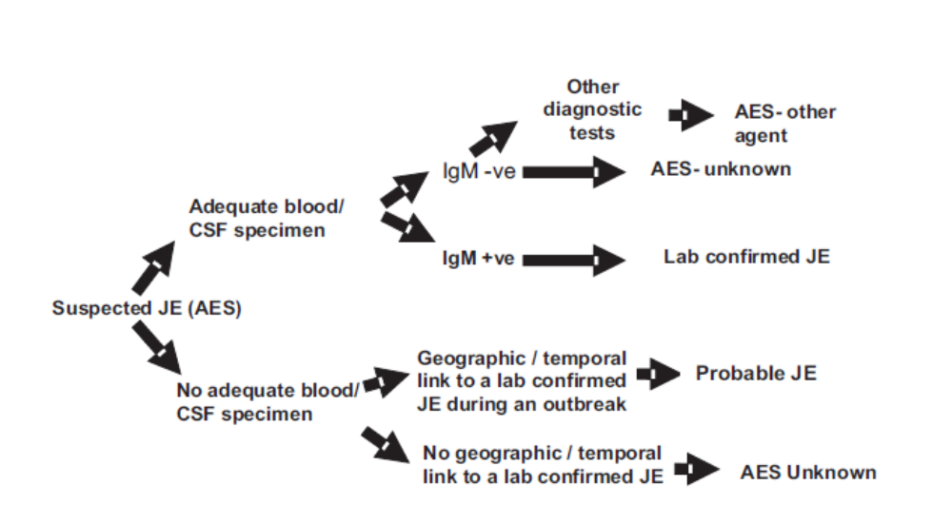
Figure 1. Flow chart for Classification of cases (Reproduced from Ref. 1)

Additionally, the process of surveillance of AES is reproduced below (Figure 2).
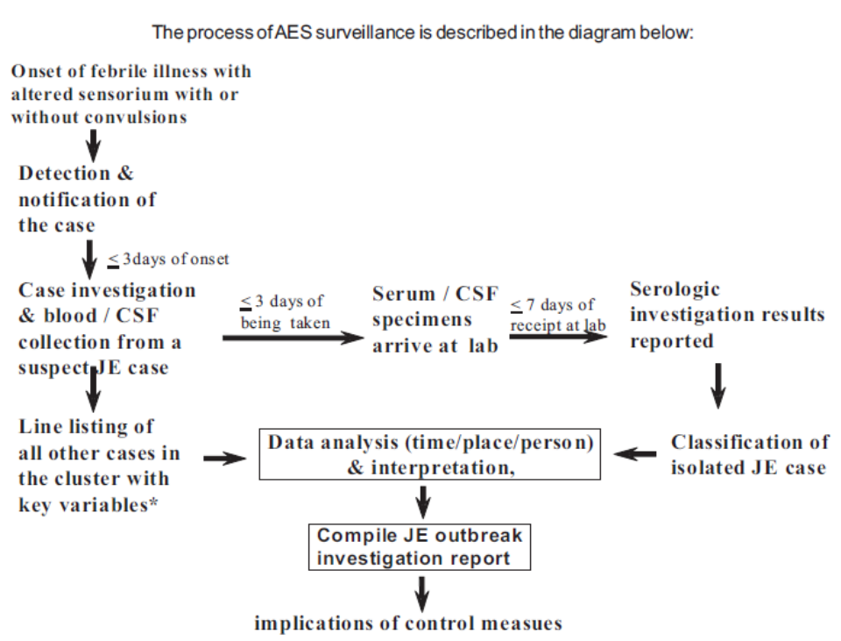
Figure 2: The process of surveillance of AES

Information flow diagram is reproduced below (Figure 3).
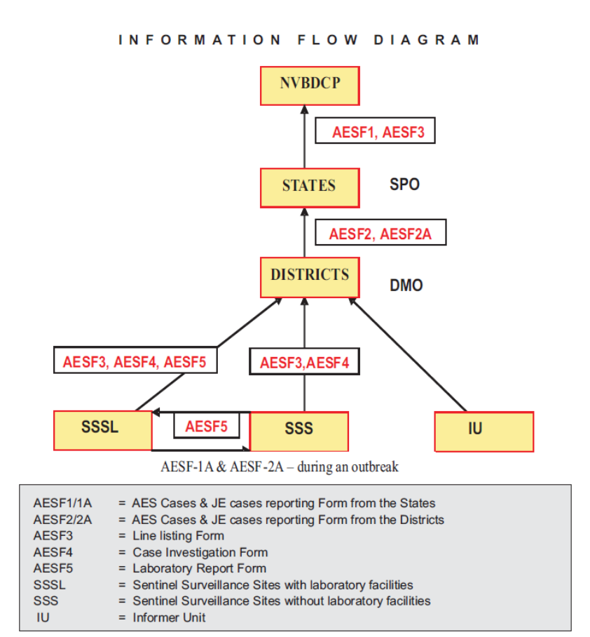
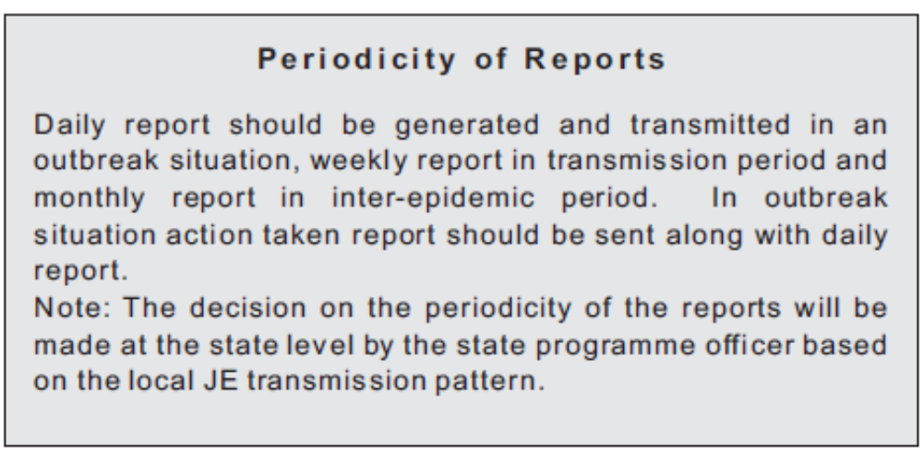

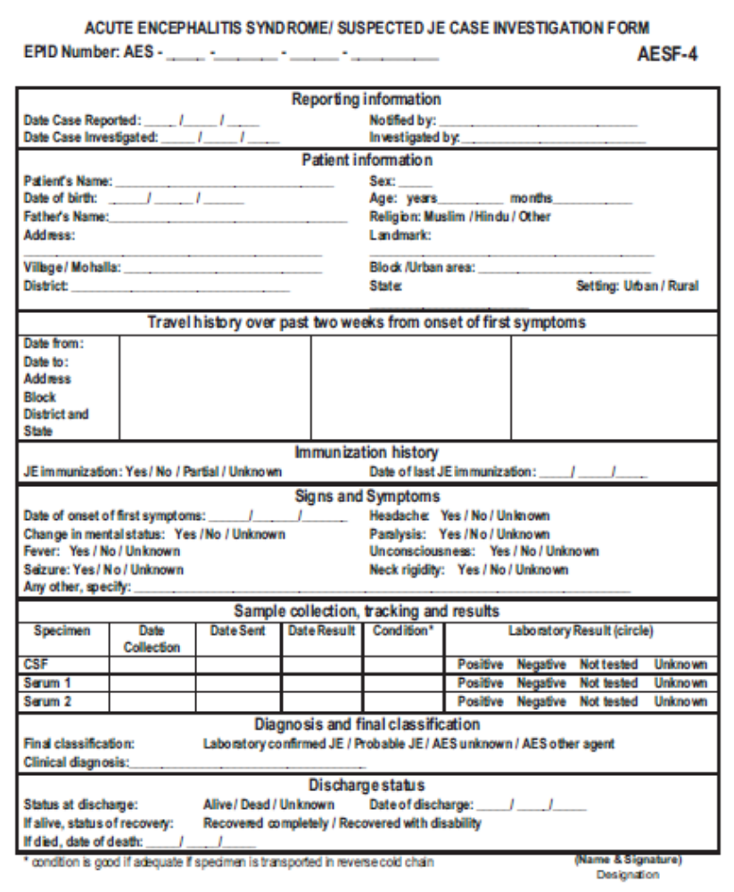
Figure 4. Case investigation form for AES/JE
Figure 5. Outbreak investigation report form

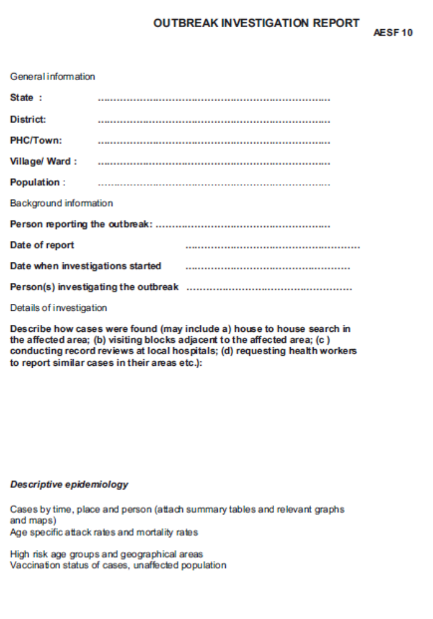
Continued on next page
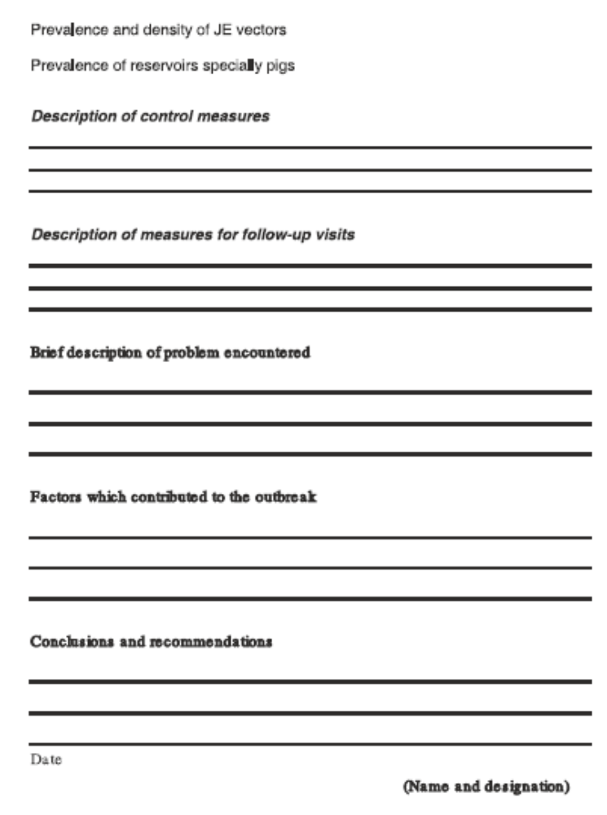

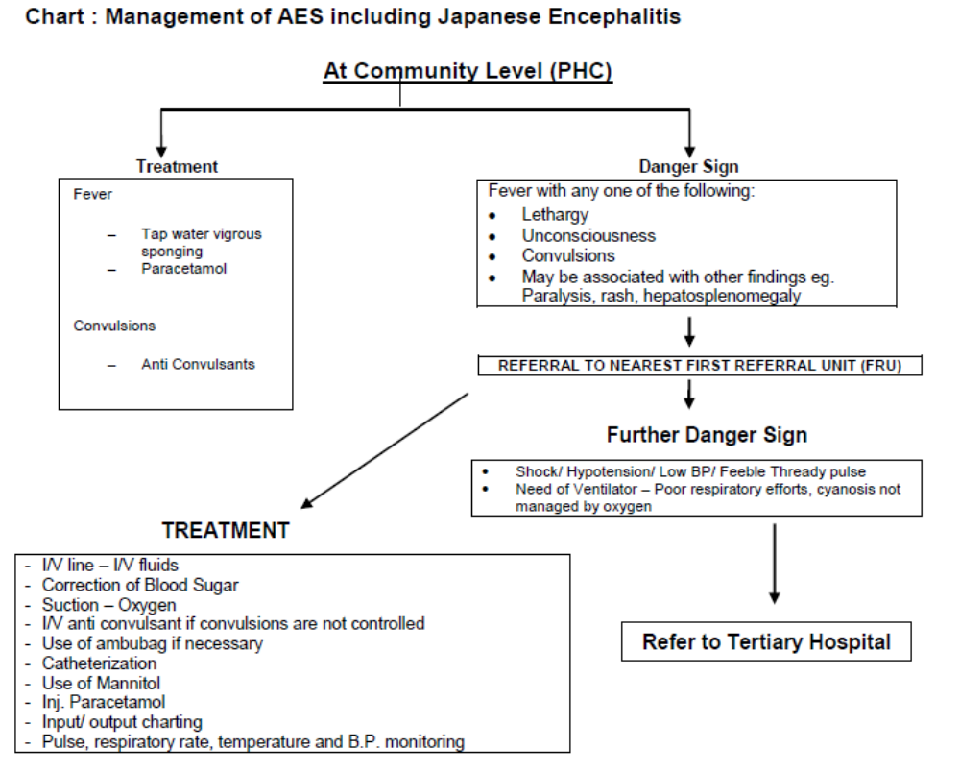Fig. 6. Case management of JE / AES at community level

Annexure 2: References used for preparing the appendix with included Annexures:
Sr | Document Name | Description | Location
1 | Guidelines for surveillance of acute encephalitis syndrome with special reference to Japanese encephalitis), November 2006 | Government of India Guidelines | Web
2 | Clinical management of acute encephalitis syndrome including Japanese encephalitis, August 2009 | Government of India Guidelines | Web
3 | National programme for prevention and control of Japanese encephalitis / acute encephalitis syndrome 9Operational guidelines), 2014 | Government of India Guidelines | Web
4 | Consensus Guidelines on Evaluation and Management of Suspected Acute  Viral Encephalitis in Children in India | Indian Academy of Pediatrics, Encephalitis expert group | Web, Sharma S et al. Indian Pediatrics 2012; 49:897-910.
5 | Operational guide-Japanese encephalitis vaccination in India, September 2010 | Government of India | Web
6 | Mission Indradhanush. Operational guidelines, 2015 | Government of India | Web
7 | National Vector Borne Disease Control Programme (NVBDCP). Monitoring and evaluation plan. Implementation phase, IMCP-Phase II. | Government of India | Wen
8 | National Vector Borne Disease Control Programme (NVBDCP). Guidelines for PIP. | Government of India | Web
9 | Sentinel site surveillance of Japanese encephalitis. Version 2.0, March 2006 | PATH | Web
10 | WHO recommended surveillance standards: Japanese encephalitis | WHO | Web
11 | Integrated disease surveillance programme. Assessment tool for status of laboratory component in states. | Government of India | Web
12 | Vaccination coverage cluster surveys: Reference manual, version 3., July 2015 | WHO | Web
13 | Case management of acute encephalitis syndrome / Japanese encephalitis. | Government of India | Web
14 | Field guidelines for the evaluation of a surveillance system | CDC | Web

Annexure 3: STUDY QUESTIONNAIRE: CASES of JE and AES
Project Title:
CRITICAL APPRAISAL OF SURVEILLANCE, MANAGEMENT AND VACCINATION OF JAPANESE ENCEPHALITIS AND ACUTE ENCEPHALITIS SYNDROME IN INDIA: PROGRAMME IMPLEMENTATION RESEARCH IN SELECTED ENDEMIC STATES
Complete from Screening Interview or Log before beginning questionnaire:
Month and Year of Birth: // Current Age: Sex :
Place of residence (village): ______________________________________________

Relationship of respondent to subject: ______________________________________

A. DETAILS OF THE RESPONDENT:
1. Are you able to read and write? Yes (Literate) No (Illiterate)

2. Please tell me the level of school education you have completed (Tick only one):
None
Primary school (Class 1- 4)
Middle school (Class 5-7)
High school (Class 8-10)
Higher Secondary school (Class 11–12)
Graduate and above
Don’t know

B. HOUSEHOLD INFORMATION:
1. How many members are there in the household? ____________
2. Please tell me the sex, age, relationship to ____ (child’s name), education level, occupation and income per month of each person in the household.
Serial No. | Sex | Age in completed  years | Relationship with the child | Education  - completed | Occupation | Income per month (INR)
- Altogether, how many siblings were born before _____ (child’s name), even if they are not still living now? _____________________
- How many rooms are there in the house? _________
5. Do you have an electricity supply in your house? Yes No
- What is the source of drinking water?
- Hand pump
- Tap
- Well
- Others

7. Which of the following items does the household own?
a) Radio Yes No
                - b) Television Yes No
                - c) Refrigerator Yes No
              - d) Bicycle Yes No
              - e) Motorcycle Yes No
              - f) Car Yes No
              - g) Telephone/ Mobile Phone Yes No
                - h) Computer Yes No

8. What are the measures taken at household level for protecting family members, especially children, from mosquito bites?
- Repellant creams applied to the skin
- Burning of mosquito coils
- Use of mosquito net
- Window/door screens
- Fully covered clothing
- Other (Specify) ______________.
- None
- Don’t know

9. Are any of the following animals/ birds being reared or kept in the household or near the house, within about 100 meters?
- Pigs Yes No
- Cattle Yes No
- Horses Yes No
- Water Birds Yes No Don’t know

C. SUBJECT INFORMATION:
Now I would like to ask you some questions about _____ (use child’s name), specifically about schooling, health status and medical care.
1. Has _____ (use child’s name) attended school? Yes No
If yes, name of the school___________ Class: ________

2. If ______ (use child’s name) gets seriously ill, which health facility would you take him/her to? ________________________________________________________
Section D should be asked only if interviewing CASE who was alive at hospital discharge; otherwise skip and go to Section E.

D1. HEALTH CONDITION AT DISCHARGE FROM HOSPITAL
a. How was ____(use child’s name) health at the time of discharge from hospital after the JE illness?
Completely recovered
Recovered, but with minor problems
Recovered, but with significant problems
Still seriously ill
If “completely recovered”, then skip Q. D1.b and go to Q. D2.
Otherwise, please ask the parents or guardians- (Do not prompt but tick the appropriate responses below and ask “Anything else?” until there is nothing new added.)
b. Can you tell me what physical or mental problems _______(use child’s name) had at the time he/she was discharged?
- Cognitive deficits
(Note, cognitive deficits will include - Impaired mental faculty of knowing, which includes perceiving, recognizing, conceiving, judging, reasoning, and imagining)
- Seizures
- Neurological deficits (disability/paralysis)
- Loss of speech
- Abnormal behavior
- Acute Flaccid Paralysis
If none of the above, name the functional deficits mentioned by the parents/ guardians
- ________________________________________
- ________________________________________
- ________________________________________
- ________________________________________
- ________________________________________

D2. SUBJECT’S CURRENT HEALTH CONDITION (SKIP FOR DECEASED)
a) How is _______ (use child’s name) current health condition compared at discharge?

Same as before

Improved

Worse

Died after leaving hospital

If died, cause of death: ________________________

Approximate date of death: __________________
If “same as before”, skip and go to E. Otherwise, go on to 2.b.
b) What are the physical or mental problems that ___ (child’s name) has presently?
- Cognitive/Learning/Schooling deficits
- Seizures
- Neurological deficits (disability/paralysis)
- Loss of speech
- Acute Flaccid Paralysis
If none of the above, name the functional deficits mentioned by the parents/ guardians
1>________________________________________
2>________________________________________
3>________________________________________

E. VACCINATION HISTORY:

This section is about the details of vaccination. Please verify the verbal responses of the respondent with the entries in the vaccination card).
I would now like to ask you some questions about _______ (child’s name) vaccinations.
1. Has ______ (use child’s name) received any of the routine vaccinations as per the Routine Immunization schedule? Yes No

If yes, then please enter in the table below. If no, go directly to Q. E3.

If they don’t know, then ask if anyone else in the household might know.
Name of Vaccine | Verbal reports of Vaccinations |  |  | Date | Place | Written confirmation  Yes/ No
Name of Vaccine | Yes | No | Don’t Know | Date | Place | Written confirmation  Yes/ No
BCG (Left arm)
DPT 1
DPT 2
DPT 3
DPT Booster
OPV 0
OPV 1
OPV 2
OPV 3
OPV Booster
Measles
Hepatitis B 1
Hepatitis B 2
Hepatitis B 3

If the child had received Measles vaccine, then go to Q. E2, otherwise go to Q. E3.
2 Where did _____ (use child’s name) receive the measles vaccination?
a) At home

b) Health center or Clinic ____________________________
c) ) Village health center or via ANM visit: _________________________
d) District health center ________________________
e) Hospital ____________________________
f) Other _____________________________
g) Don’t know
If the child was never vaccinated or was partially vaccinated, ask Q. E3. If the child has received all the Routine Immunization vaccines then skip Q. E3 and go to Q. E4.
3. If ______ (use child’s name) was never or only partially vaccinated with routine immunizations, please tell us the reasons why some vaccines were missed.
(Please do not read out the reasons but try to record reported responses based on reasons provided by the respondent/informant. Tick the appropriate answers in the boxes.)
- Vaccination center or clinic too far away
- No vaccine at the vaccination clinic
- Sick child at home
d) Fear of vaccine side effects
e) Vaccination clinic was closed
f) Shortage of money
g) Did not know vaccines were needed
h) Other (specify)
4. Was ________ (use child’s name) vaccinated with JE vaccine during the campaign in ______(enter dates)? Yes No Don’t know
(If No or Don’t know, skip to Q. E6.)
5. Where did _______ (use child’s name) receive JE vaccine?
- Primary Health center (PHC)
- District Hospital
- School
- ICDS centre
e) Others
Name of the facility where the child received vaccination _____________________________________________________
f) Don’t know
6. Can you please ask _______ (use child’s name) if he/ she remembers whether he/she was vaccinated with JE vaccine?
Yes (received)
No (Did not receive)
Does not remember
Child not available or able to answer
Parent prefers not to ask child

(If yes) Where does _____ (use child’s name) remember being vaccinated?
- Primary Health center (PHC)
- District Hospital
- School
- ICDS centre
- Others
Name of the facility where the child received vaccination _____________________________________________________

If the child was not vaccinated, ask Q. E7; otherwise skip Q. E7 and go to Section F.
7. Please tell us the main reasons why _____ (use child’s name) was not vaccinated for JE. (Tick the appropriate boxes below).
- Vaccination center or clinic too far away
- No vaccine at the vaccination clinic
- Sick child at home
- Fear of vaccine side effects
- Vaccination clinic was closed
- Shortage of money
- Did not know vaccines were needed
- Don’t know
- Other (specify) _________________

If child was vaccinated go to section F, if not vaccinated, skip section F and go to end.

F. VACCINATION CARD OR RECORDED JE VACCINATION HISTORY

1. 1. Do you have a card that ______ (use child’s name) got when he/she was vaccinated for JE? Yes No

(If yes) Can you kindly show me the card?
Is the vaccination card available with respondent? Yes No

If yes, then enter the date of vaccination and location as per card records.

(If “no” or “don’t know”, then the vaccination records will have to be verified by the Field Interviewer 1 at the PHC/SC and the details recorded on Page 11, section G ).
Take this opportunity to educate the child’s family about JE disease and the importance of vaccination and other control measures. Refer the unvaccinated subjects for vaccination to the medical officer of the concerned health centers. Thank the respondent for providing important information that will help us understand the benefit of JE vaccinations in preventing disease. If child is deceased, also convey condolences for their loss. Terminate the interview.
Field interviewer: Name______________________________
Signature: ________________________ Date _________________
Reviewed by Field supervisor: Name _____________________________________
Signature: ________________________ Date _________________

G. For the Vaccination Card reviewed at PHC/ SC by the Field Interviewer 1, please make the entries below:

Was the vaccination card available at the PHC/SC? Yes No
If not, did you find a record elsewhere? Yes No

If yes, enter the date of vaccination as per card or records _________________

Enter the location where vaccination had been given to the child.
____________________________________________________________________

Field interviewer: Name______________________________

Signature: ________________________ Date _________________

Reviewed by Field supervisor: Name _________________________________

Signature: ________________________ Date _________________

Reviewed by Field coordinator: Name ____________________________________

Signature: ________________________ Date _________________

